Hardcoded Settings

What Are Hardcoded Settings?
# Source: AI Source: Provided by: [Data Path: Persons Table -> ID Column: 1, Name_En Column: Motasem Essam] -> From: [ChatGPT] on [1/26/2026]
Hardcoded settings are values or configuration options that are directly written into the source code of an application instead of being stored externally (like in a config file or environment variable).
- In other words, the value is “fixed” in the code and cannot be easily changed without editing the program itself.
- This is generally not recommended for sensitive data or things that might change frequently.

Example of Hardcoded Settings
# Source: AI Source: Provided by: [Data Path: Persons Table -> ID Column: 1, Name_En Column: Motasem Essam] -> From: [ChatGPT] on [1/26/2026]
Example in JavaScript:
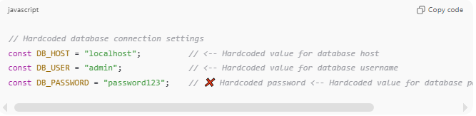
// Hardcoded database connection settings
const DB_HOST = "localhost"; // <-- Hardcoded value for database host
const DB_USER = "admin"; // <-- Hardcoded value for database username
const DB_PASSWORD = "password123"; // ❌ Hardcoded password <-- Hardcoded value for database password (not secure!)
Problem:
- If the password changes, you have to modify the code and redeploy the application.
- If someone gets access to the code, they can see the password—security risk.
Better approach (using environment variables or config files):
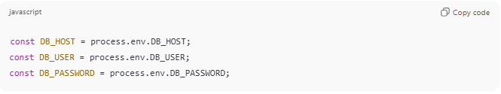
const DB_HOST = process.env.DB_HOST;
const DB_USER = process.env.DB_USER;
const DB_PASSWORD = process.env.DB_PASSWORD;

Characteristics of Hardcoded Settings
# Source: AI Source: Provided by: [Data Path: Persons Table -> ID Column: 1, Name_En Column: Motasem Essam] -> From: [ChatGPT] on [1/26/2026]
- Fixed in the code, cannot be changed dynamically.
- Often includes paths, credentials, API keys, or default values.
- Hard to maintain, especially in different environments (development, testing, production).
- Can pose security and scalability risks.

When People Use Hardcoded Settings
# Source: AI Source: Provided by: [Data Path: Persons Table -> ID Column: 1, Name_En Column: Motasem Essam] -> From: [ChatGPT] on [1/26/2026]
- Quick prototypes or demos
- Internal tools with limited access
- Defaults that rarely change (though even these are better in config files)

Hardcoded vs Configurable
# Source: AI Source: Provided by: [Data Path: Persons Table -> ID Column: 1, Name_En Column: Motasem Essam] -> From: [ChatGPT] on [1/26/2026]
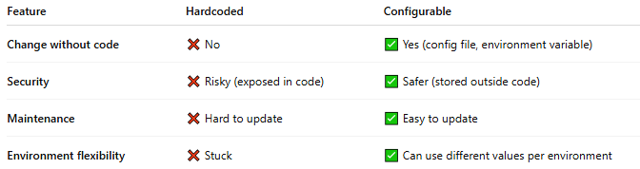
Feature | Hardcoded | Configurable
Change without code | ❌ No | ✅ Yes (config file, environment variable)
Security | ❌ Risky (exposed in code) | ✅ Safer (stored outside code)
Maintenance | ❌ Hard to update | ✅ Easy to update
Environment flexibility | ❌ Stuck | ✅ Can use different values per environment

💡 Analogy:
# Source: AI Source: Provided by: [Data Path: Persons Table -> ID Column: 1, Name_En Column: Motasem Essam] -> From: [ChatGPT] on [1/26/2026]
- Hardcoded = writing your home address on every envelope you send
- Configurable = storing your home address in a single notebook and referencing it every time

